**“Attendance Managemant System” using Face Recognition and Cloud**

N.V.V. Ramana Reddy   
Electronics and Communication Engineering  
KG Reddy College of Engineering & TechnologyHyderabad, Telangana, India  
ramanareddy0976@gmail.com

K. Manoher Reddy  
Electronics and Communication Engineering  
KG Reddy College of Engineering & TechnologyHyderabad, Telangana, India  
kmreddy8106@gmail.com

Vijaya Bhasker Reddy  
Electronics and Communication Engineering  
KG Reddy College of Engineering & TechnologyHyderabad, Telangana, India  
vijayabhasker@kgr.ac.in

R. Deepak Reddy  
Electronics and Communication Engineering  
KG Reddy College of Engineering & TechnologyHyderabad, Telangana, India  
deepakreddypokemon@gmail.comPyla Sai Karthika  
Electronics and Communication Engineering  
KG Reddy College of Engineering & TechnologyHyderabad, Telangana, India  
karthikapyla@gmail.com

*Abstract*— **In Universities, collages and schools’ attendance is one of the major important task and key role that must be done on a daily basis every day. The attendance system is used to track the student whether they are attending the classes or not. There are many different types of attendance monitoring systems such as Radio-frequency Identification system, Biometric based systems, paper-based attendance system and Facial-recognition systems etc. Traditional methodology for taking attendance is by calling students name or roll number and then the attendance is recorded in the sheet. The traditional methodology has a lot difficulty which causes non-reliable and error in attendance while taking it in the class. For each lecture its wastage of time and few students may miss their attendance. It’s very difficult to cross-verify the students attendance and it consumes more time to avoid the loses, in this paper we propose a system called “ATTENDANCE MANAGEMENT SYSTEM BASED ON FACE RECOGNITION” it is more safety and time saving process. The process, which is based on the method of detection of face and recognition by using the method of Convolutional-Neural-Network (CNN) algorithm, which automatically scan/detect the student’s face whenever the respective student comes to the class room and then it mark the attendance of that student by Identifying the particular student by extracting the image. This particular model will records and also store’s the recorded attendance of that student in class and then redirected it to the database. The student database includes the student’s name, roll numbers and their images. When a student is noticed/recognized, the attendance of that student will be taken autonomously and it saves only necessary information into a excel sheet from database. Finally, the excel sheet which contains the attendance of the student. That particular information will be sent to the respective faculty and student. The design and algorithms used in this paper in each stage are described.**

Keywords— *Radio-frequency, face recognition, students, Convolutional Neural Network (CNN), Data base*

I. INTRODUCTION

Being a literate human being we all know how attendance plays an important role in a student life. The main purpose of attendance is keeping record of the students in an organization. Generally, it refers to the act of being present at that moment in an organization.

Attendance is arguably one of the major important indicators of a student in school life. Attendance is also powerful predictor of student’s performance and outcome of the results. Not only in the school’s but also in the workplace (or) social events, attendance plays an important role in determining the individual’s discipline towards their respective organizations.

Consistent attendance of the student shows us the commitment and responsibility, which are basic essentials for the student’s career growth. Now the next thing is we know how attendance is being taken in the schools. the general and traditional way of considering the attendance is by calling the roll no’s and the names of the students by teachers.

As increased innovation in the technology nowadays there are various methods (or) ways are there to consider the attendance. For example, biometric identifiers which identifies the finger print, face recognition, palm print, geometry of the face, iris recognition etc. it is the fact that the general way of considering the attendance looks very cheaper and easy but here comes the problems like wastage of time, basic calculation errors in attendance percentage, roll call of the students can be missed etc.

To overcome all these problems which occurred in general method of considering the attendance we go the advance method of considering the students or employees attendance. In this paper we discuss about the attendance management system based on face recognition. attendance for the students is considered through mobile application in which the students should submit their respective attendance by scanning their faces using their individual mobile camera.

Firstly, Face recognition which refers to the process of giving the computer the ability to identify the human facial features of a student. And here the algorithms of machine learning quickly collect/captures the faces. And one more fastest advantage of these algorithms are it also matches the captured image with pre-existing images to build a connection. The ML algorithms are continuously trained using different points on the face of the student. the extraction could be the border of the human eyes, Nose tip of a human, bottom of the chin etc… after locating the points on the face it turn them towards the mid-point to arrange and match it to the database [1].

**Majorly there are different types of face recognition algorithms:**

* Eigenfaces
* Local Binary Patterns Histograms (LBPH)
* Fisher faces
* Scale Invariant Feature Transform (SIFT)
* Speed Up Robust Features (SURF)
* Convolution neural network (CNN)

A Convolutional Neural Network is a type of Deep Learning neural network architecture which is commonly used in Computer Vision. it is a field of Artificial Intelligence that enables a computer to understand and interpret the visual data. When it comes to Machine Learning ANR (Artificial neural network) perform really well. CNN is used in various datasets like images, text, speech etc…. Various types of Convolution Neural Networks are used for various purposes, for example for predicting the sequence of words we use RNN (recurrent neural network) more precisely an LSTM, and also for image classification we use the (CNN) Convolution Neural networks. In a simple terms Convolutional Neural Network (CNN) is a type of neural network which is made to process the data/information through multiple layers of the array. It is well suited for the applications such as face recognition [2].

**CNN Architecture**

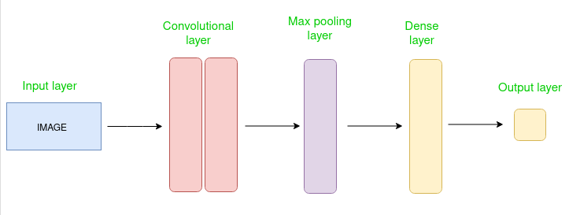

Figure 1: Architecture of Convolutional Neural Network [15].

Convolutional Neural Network consists of different layers where the first layer is the input layer then followed by Convolutional layer, Pooling layer & fully connected layers (output layers).

Generally, the Convolution neural network (CNN) uses a mathematical operation called the convolution. Here we define convolution as the mathematical operation on which the 2 functions (f ) and (g) will produces the third function. The third function will express how the shape of one graph is modified by the other.

In the concept of (CNN) the convolutional layers are the major blocks which make the expected output. In a particular image/picture recognition application, Convolutional Neural Network which is made up of several layers to locate the features of an image.

For example, when a person is walking towards you from a particular distance. Then generally, eyes will try to locate the edges of a particular person and then we try to compare that particular person from the objects like vehicles, tall-buildings etc. secondly, when the person comes near to us we mainly see or focus on the person’s outline. After that we conclude that the person is female or male Plump or thin etc.. Finally, if that person reaches near us then our eye focus shift to the facial features of the person whether he/she is wearking Mask, specs etc.. so from the above mentioned example here we can conclude human eye focus shifts broad-features to only a particular features. Therefore, in a Convolution neural network there are several layers which consists of different filters these filters are also called as “kernels” which in charge of locating/pointing a particular feature [3].

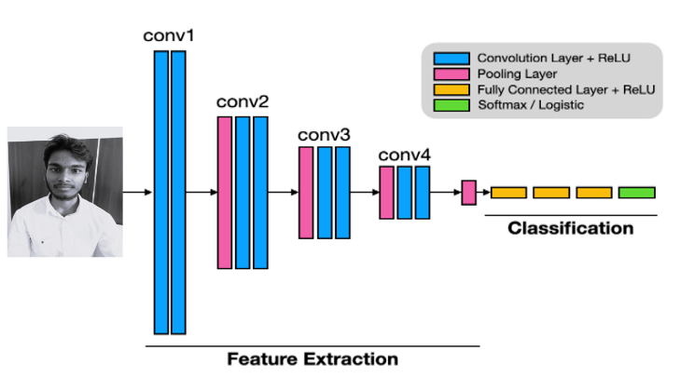Figure 2: Image classified through feature extraction[16].

The above image shows a convolution neural network of network. In the image we can see the first few layers from conv1-conv4 these layers will detect the different characteristics in an image. the characteristics can be shapes, outline, edges etc. Lastly, the final layers will conclude the result whether the picture contains human-face belongs to a person 1,2 or 3. Here, the pooling layer in CNN is mainly used to deduce the size/dimensions of an image and increase the speed of calculations. And also helps it to become more efficient.

**Haar Cascades**

Let us discuss about the Haar cascades these Haar cascade is an algorithm which mainly used in the purpose of object detection in imgaes/pictures with ignoring the scale within the image. This Haar algorithm is not as much as complex as we think these can easily run in the real-time. It is very simple to train the Haar cascade detector in detection of different objects such as tall buildings, vehicles, persons, chairs and many more…

One more special thing about Haar cascades is it uses the cascading windows and it tries to compare the features in each window and then finally it classifies whether the object can be detected or not.

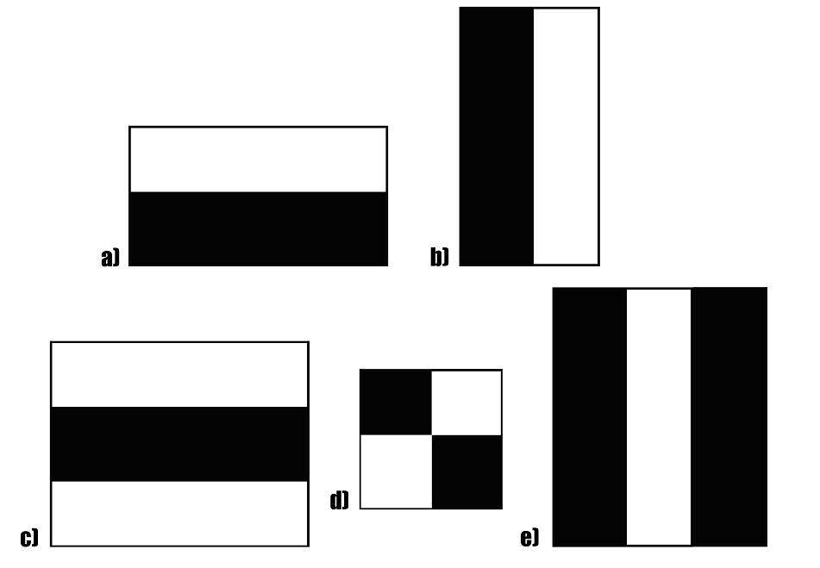

Figure 3: Object detection using haar cascade[17].

The Haar algorithm can be explained in four stages:

* Calculating Haar Features
* Creating Integral Images
* Using Adaboost
* Implementing Cascading Classifiers

## Calculating Haar Features

The Initial step is to gather the Haar features. The features of haar are must and should calculation which is performed in the rectangular regions at a particular location in a window. This calculation shows the addition of the pixel strength in each region and calculating the differences between the sums.

Below image shows the example of Haar features: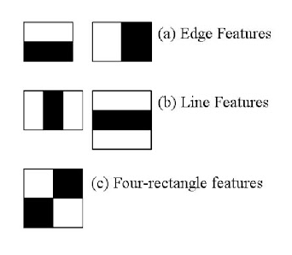

Figure 4: Features of haar cascade[18].

Whatever, the features mentioned might become some difficult to decide or determine for the larger picture/image. Due this drawback the integral images has been introduce because in the integral images the number of the operations will be reduced [4].

## Creating Integral Images

In this Integral Images there is a mathematics so for now it is not much necessary going that depth of the mathematics with this concept. The images which we have integrated those images speed up the calculation of features of Haar. In this concept it uses a very simple concept like instead of calculating at each pixel it creates a unique way of sub-rectangles and after the creation these sub-rectangles are used to calculate the features of Haar.

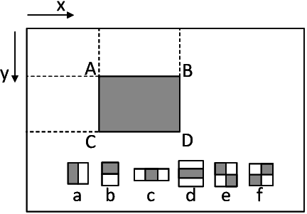

Figure 5: Illustration of the integral image and haar-like rectangle features(a-f)[119].

Here’s a thing to notice that whatever the features of the Haar will be not relevant while we perform detection of an object, the reason is due to features that are only important which belongs of the object. so, here we can conclude that we cannot observe the best features which represents an object. We can say this is a drawback. To eradicate this drawback Adaboost has been introduced.

## Adaboost Training

This Adaboost essentially chooses the best features and trains the classifiers to use them in an effective way. This is a combination of two classifiers they are “weak classifiers” to create a “strong classifier” that the algorithm can use to detect objects. Weak classifiers are created by moving a window over the given input image, and computing Haar features for each subsection of the image. Here, the difference is compared to a learned threshold that separates non-objects from the given objects. Because these are “weak classifiers” a large number of Haar features is needed for accuracy to form a strong classifier for a reliable output [5].

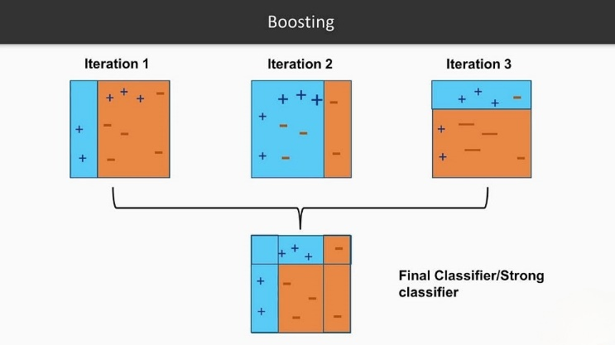

Figure 6: Boosting weak classifier to strong classifier[20].

By observing an above image we can say that the last mentioned step concatenates these weak learners to strong learners by using the cascading classifiers.

## Implementing Cascading Classifiers

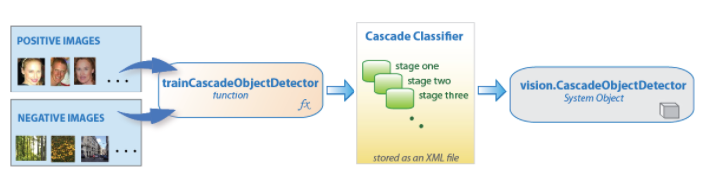

Figure 7: working of cascade object detector[21].

From the above image, The final classifier of cascade is built of series of levels. In which each level is a collection of weak learners. These weak learners then trained by the methods of boosting. After the completion of training it allows for a accuracy which is very high from the basic analysis of the weak learners.

Generally, these levels are designed in order to reject negative samples, because it is important to maximize a low-false-negative rate.

Also an important note that Haar cascade is the one which is very important to reduce the low-false-negative rate. So, by this note we should aware of hyperparameters [6].

II. LITERATURE STUDY

**Mobile Based Attendance System: Face Recognition and Location Detection using Machine Learning**

M. S. Mubarak Alburaiki, G. Md Johar, R. A. Abbas Helmi and M. Hazim Alkawaz. Every educational institution has its own way of marking the attendance to the students. Most often we see roll call based attendance in our daily life. In this project the attendance for the students is considered through mobile application in which the students used to submit the attendance by the method of face scanning using their individual mobile-camera, also with their respective current location. Firstly, Face recognition which refers to the process of giving machines, tools, and software the ability to identify the different facial features of an individual. and The Machine learning algorithms quickly capture faces, collect, and retrieve different facial features which also matches them with pre-existing pictures to form a connection. In this proposed project we are using there are three main components. Firstly, automatic face detection and analysis using mobile cameras of an individual. Secondly, we use face recognition API (Application program interface) which uses the machine learning algorithm and the final component is which maps the API. The extraction of face could involve the outside border of the human-eyes, tip and top of the nose, chin bottom. Finally the ML algorithm is repeatedly trained using different data sets/locations to locate these collected points on the face and turn them towards the centre to align to match to respective database Using this proposed system, we are having several benefits Such as it reduces the possibility of fake attendance because the system verifies the individual's identity through face recognition and then it eliminates the need for paper-based or rollcall attendance. which can be time-consuming. Finally, it provides real-time data on attendance, which can help organizations and educational institutions to manage attendance more effectively. In this project they used the (HOG) Histogram of Oriented Gradients. One of the most popular, efficient and successful "person detectors" is the Histogram of Oriented Gradients with LBPH (a type of machine learning algorithm for the classification). After conducting the testing process in educational institution, the project result shows face recognition using ML algorithms had been succeeded a higher accuracy of locating student’s faces even in a dull environment mode. It has been revealed that over 80-85% of the students are satisfied with the face recognition process. The use of the ML algorithms makes the proposed system more efficient, accurate, safe and secure[7].

**JomRFID Attendance Management System**

Q. Y. Tan, P. S. Joseph Ng and K. Y. Phan. As we all know the Attendance is an essential aspect of academic and also for the professional life, and the importance of attendance cannot be overstated. Attendance refers to the act of being present of a student at a designated location. JomRFID Attendance Management System is a system which uses the RFID (Radio Frequency Identification) technology to manage and consider the attendance in organizations and educational institutions. Nowadays The RFID system is very common in various industries and also the RFID system is deployed within various fields like transportation, medical and many more fields. RFID is widely emerging in the world due to its attractive features such as good reading ranges, high data efficiency, high reliability and its low cost. It is a is a modern way of attendance management system that uses RFID technology to manage attendance in organizations and educational institutions. RFID reader contains an antenna that emits the radio waves in which the tag responds by sending back data stored in it to the reader. JomRFID is very user-friendly and very convenient to every individual. students can easily scan their ID cards to record their attendance in school or college. Hence, by the conclusion we can say that the respective faculty can save up the time on the attendance when taking it manually. As a result, by implementing the RFID system for considering the attendance in institutions makes it very simple and efficient [8].

**Classroom Attendance Monitoring Using Biometric:**

M. R, M. D and R .P. In this paper we can see that attendance is considered using biometric in the classrooms. Managing the attendance of each and every student during the class time has become a very difficult task. Computer capacity to calculate the total attendance of student becomes a very big task because manual calculation generates many errors/mistakes, also wastes a lot of time and sometimes the papers might be missed. Here the biometric involves using unique physical or behavioural characteristics such as fingerprints, facial recognition, or iris scan to identify individual student or employee. This Classroom Attendance Monitoring Using Biometric has been continued by the software that uses passwords for security purpose. The main objective of the project is to save the time. After conducting the survey, we got to know that general attendance method takes a time for 80 students approximately 18 sec. while when the attendance was taken by using biometrics it just took 4 seconds of the time, we can see the major difference here. After considering the attendance by using biometric the system successfully took the attendance during classes and examinations. This system finally achieved the capturing of latest fingerprints of the students which has to mainly store in the database and the captured fingerprints should be placed on the device sensor now in this final step these scanned fingerprints should be compared with that previous fingerprints which are initially stored in the database [9].

**Neural Network based Biometric Attendance System:**

R. P. Vandana, P. S. Venugopala and B. Ashwini. As we know that the technology has been emerging day by day. In the emerging world not only the technology but also the education system has been reached to the new destination due to the introduction of the concept called smart classroom. As all the classrooms moved to dustless and very user-friendly in the new era of smart classroom. In this paper they discussed about the attendance is considered without the human interference. Neural network-based biometric attendance system which provide an efficient and very accurate way of monitoring the student’s attendance. neural network is one of the types of machine learning algorithm which learns the patterns from the data and makes the predictions based on the learning. One of the major rules for the neural network based biometric attendance system is that it should relevant to the laws and regulations related to data privacy and security. Proper safeguards must be put in place to protect the student’s personal information and the biometric data and also it should ensure that it is not used for any unauthorized or unethical purposes. In this proposed system a camera will be fixed in the classroom then the camera will take a photograph of the the image. the faces are detected/located and they are compared with the faces which are stored in the database and finally the attendance is marked. This proposed system have a new feature which is image based face live detection method for discriminating two-Dimension paper masks of the student from the live faces of the individual person. There are freely available or open-sources of ML and deep deep learning tools are available for example Keras & dlib are most popular in making these kind of real time applications much more faster and reliable[10].

**Attendance Management System using Facial Recognition:**

P. Sarath Krishnan and A. Manikuttan. In the recent years Facial Recognition have a remarkable upgradation and it became one of the popular features of security. we usually see it in mobile phone to unlock the device. Attendance Management System using Facial Recognition is a kind of software application which uses an advanced facial recognition technology to accurately take the attendance of a student. Generally, LBPH is a most commonly used feature for an extraction technique in computer vision, especially in the facial recognition field. It is an extension of the Local Binary Patterns algorithm and also uses a histogram of Local Binary Patterns codes to represent the image. This system has been proposed because the first and foremost thing that is happening in the schools and colleges is responding for the roll calls twice or missing the roll call of a student. Hence to eradicate this problem as well as it also maintains the set of records which is quite a difficult task. After Considering the face recognition of an individual student the data is aggregated into the database. In this paper an automated attendance management system which is used in real time by using the technique of face recognition is used to deduce human interface and therefore saves the time while taking an attendance. A modified LBPH algorithm is also used it is mainly based on the pixel neighbourhood grey-median for identifying the main characteristics of the students facial features for producing much accurate result. This kind of face recognition technology is much faster than the general attendance methods such as manual entry (or) swiping of the Identity Card[11].

**SAMS: An IoT Solution for Attendance Management in Universities:**

G. Sittampalam and N. Ratnarajah. Here, the SAMS stands for Smart Attendance Management System which is an IOT based solution for managing the attendance in many top universities in which it uses both hardware and software components to start or automate the attendance process and improving the quality. The hardware component Smart Attendance Management System of consists of IOT-based devices such as RFID readers, biometric sensors which captures the attendance data in real-time. Hence the Students can use their RFID enabled Identity cards. And also, they can use the biometric features such as fingerprint, iris recognition and facial recognition to mark their attendance. The captured student’s attendance data is transmitted to the cloud-based software platform for processing the further steps. The software component of Smart Attendance Management System provides a user-friendly interface to the users for managing attendance data which also generates the reports and monitors the attendance trends. This system also provides real-time alerts for attendance exceptions to the users such as late or absent for the students. Hence, the attendance data captured by Smart Attendance Management System can be analysed to identify patterns and trends, enabling universities to make data-driven decisions to improve student attendance management this kind of systems can also inhibit the interest in the students to attend the college regularly [12].

**Automatic Attendance Marker Using Beacon technology:**

A. Hake, A. Samanta, P. Kasambe and R. Sutar. An Automatic Attendance Marker based on Beacon technology is also an IoT-based solution which utilizes the small Bluetooth Low Energy (BLE) devices known as beacons to track attendance in real-time. Beacons are the small, battery-powered devices that transmits the signal to the nearby smartphones or other Bluetooth enabled devices [13].

**Face Recognition Method for Online Exams**:

A. A. Sukmandhani and I. Sutedja. Face recognition is one of the popular methods used for online exams to confirm that the authenticity of the student taking the exam or not. It also involves using computer vision algorithms to identify the face of the student uniquely and match it with their registered photo ID to confirm their identity as true or fake. Before the exam starts, students are mandatorily required to register their photo ID after the registration then it is then stored securely in the database. During the exam of a student, the student's webcam is turned on, and then computer vision comes into the picture this algorithm starts capturing the images of the student's face at regular interval of time. And then after images captured by the webcam are compared with the registered photo identity card (ID) using face recognition algorithm. The algorithm analyses facial features such as the shape of the face, nose, eyes, jaw-line mouth, and matches them with the photo ID of the student which was registered before the exam. If this algorithm determines that the student's face matches their registered photo ID, they are allowed to continue with the examination which is going on and proof for the presence of the students. Elsewhere If there is any mismatch, an alert will be triggered, and the student's exam is flagged for further review or he may quit the exam.

The system also monitors any suspicious behaviour, such as sudden movements, multiple faces in the camera frame, which could indicate the alert that someone else is taking the exam and then the exam is flagged [14]

III. Existing Solution

Contrary to our proposed system, there are many existing solutions to the problem that was mentioned above. They use different technologies and methods for a better attendance management. Some of them are below.

1. Using PCA algorithm

In this system, they have used a mobile phone camera along with machine learning algorithm (PCA), which is commonly used for face detection and low-end face recognition. The overall price of the system is comparatively less and very portable to use. Students can mark their attendance while using their own mobile phone camera.

b) RFID Technology

The method to use RFID technology is very common and it is mostly used in shopping malls etc., But here, the student id cards function as a RFID tag and using a RFID reader, they can scan their cards to mark their attendance. It is very simple to use.

c) Beacon Technology

A Bluetooth beacon is used, which has the radius of 2-3 meters. It detects the presence of the students through their own smartphone Bluetooth, which has a unique ID. The student needs to be present in the allocated range for his attendance to be marked as present.

d) Minutiae based Algorithm

In this, the biometrics like fingerprint are taken as a method to mark attendance. The students need to scan their fingerprint after entering their unique id, then the device will match the fingerprint data to check for the similarities along the ridge pattern. The Minutiae algorithm is used for this as its coverts the 2D scanned data into a 3D model for analyzing.

e) LBPH Algorithm

The algorithm uses face liveliness to detect and recognize faces. It takes around 200 images of each student for a better recognition. It first finds faces, posing or working faces, differentiates them, encode them, and find the person encoded through database. But the system is implemented only for online use, where for classes, using the laptop camera, the attendance of students is marked.

Through our proposed system we tried to solve most of the cons in the current existing solution. It is relatively cheaper, fast and secure. Using CNN algorithm, it detects and recognizes faces in real time while also maintaining an accuracy rate of more than 90%. The reliability is more and as we have made a physical module, it can be directly used in the class. It is better at crowd sensing and works just with one image for each person. CNN algorithm separates a single image into multiple layers and using HAAR classification, it segregates positive and negative data points to be able to better detect the student’s face.

IV. METHODOLOGY

An Attendance management system is developed, which uses face recognition as its primary method to mark attendance of a student on a daily basis. It is a convenient method, developed to replace the traditional method of taking attendance in a class. At the end, the system provides a list of data of students that are marked present in the .csv format. The main components used are raspberry pi and a portable camera for its real time image processing, interfacing and IOT connectivity. The user related work is done here which also includes taking inputs or converting given data sets. Later, at the backend, firebase, an open-source cloud-based web application platform is used, which acts as a database for the system.

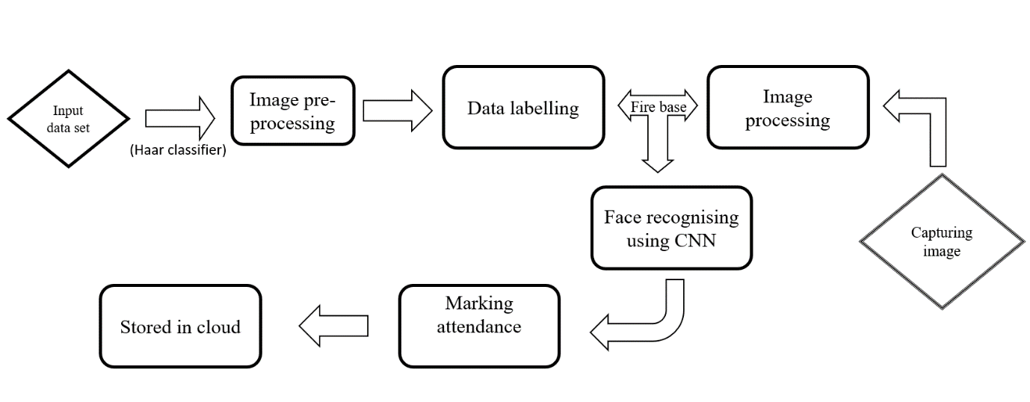Figure 8: Functional diagram of attendance management system

As we could imagine, in the tradition method of taking attendance, for a student, there is chance to miss the roll call. It also effects his daily evaluation, where the fault lies in the method of taking attendance. So, a system where it is replaced with a more accurate and less labor involving is proposed here. It also helps for time consistency of a teacher by allowing them to utilize an allocated period of time just for teaching and nothing else.

We feed in all the data sets, where, a set of facial data of the student is collected through an external camera model. Each image covers the entire face from the front for a better detection and more accurate results in real time. Each image is of resolution 1024*768 and is converted to 786432*1 and stored in the firebase, an open-source cloud-based application platform. Using CNN algorithm, the attributes of each face is converted into 128 mathematical numbers and stored in the database. While take the live input, the image is processed through multiple layers in CNN to compare the stored data and the input data as shown below.

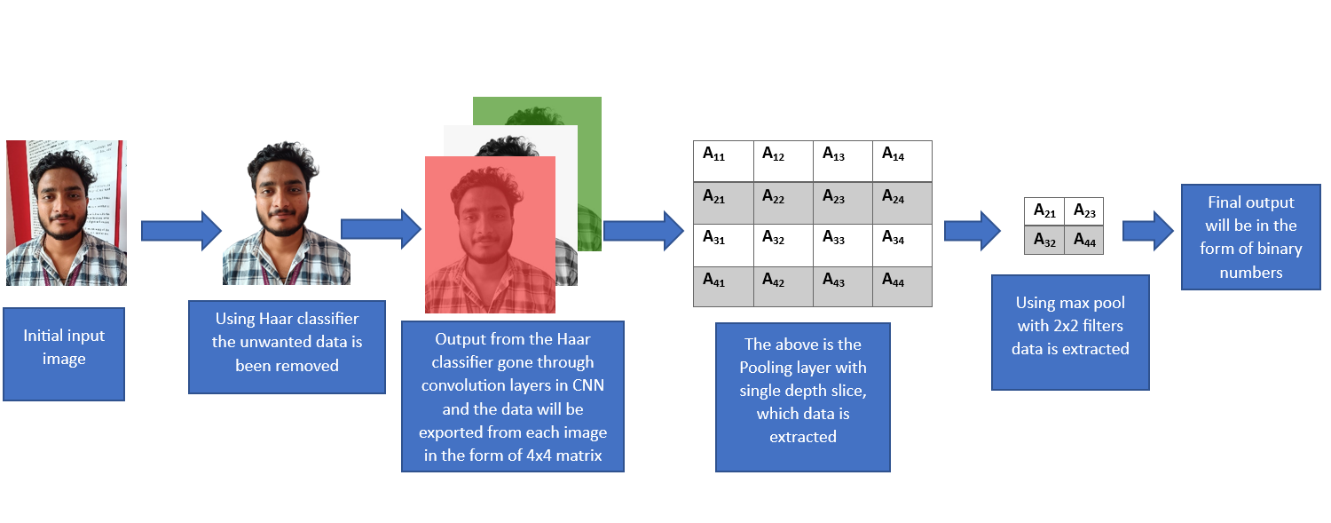

Figure 9: Overall working model of CNN using haar cascade classifier

With an external pi 3b camera module, the face of the student is captured in real time, when he enters the classroom and the input is immediately stored in the local database with a .rasp file name. The face data matching is done by comparing the input data and the stored data. If the face attributes of given data are matched with an pre-stored dataset, then it gives out the output of the student name it is matched with and stores it in excel sheet format in the cloud. It becomes accessible to people with right credentials, usually, a teacher or as student.

IV. RESULTS AND DISCUSSION

After the module processes the received inputs, the face of the person in front of the camera is recognized and the outputs are generated.

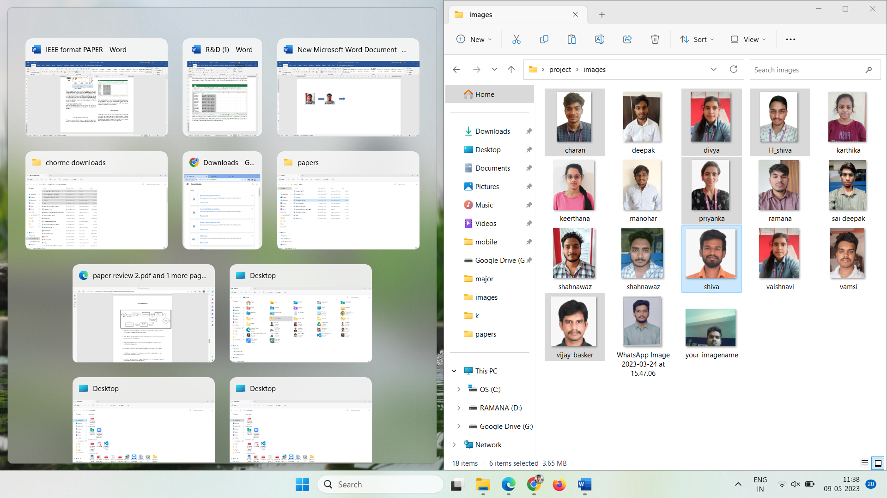

Figure 10: Collected data of n number of students.

The data sets are stored in the local storage path and uploaded to firebase, which we are using as a database here. Here we have taken images of around 18 students and each image has the student’s name to it.

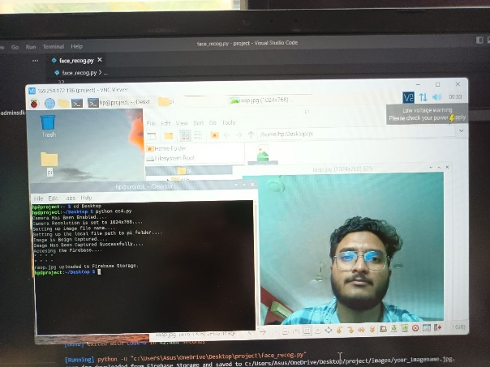

Figure 11: Captured image through pi 3b camera module and processed.

The above figure shows us how the inputs are taken. We have used a raspberry pi 3b camera module, an external camera connected to raspberry pi to take the photo. It is mainly to capture a more clarity photo of the subject shown above. It has a default resolution of 1024*768 but can be changeable.

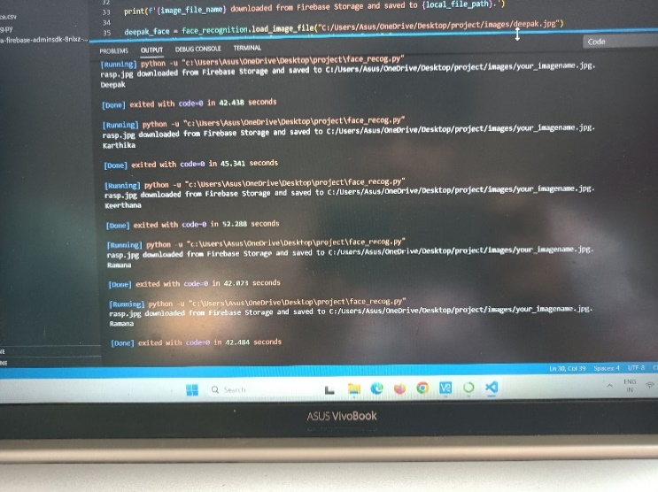

Figure 12: Processing time of multiple inputs.

As we can observe, we have processed the inputs multiple times to check for any errors or time delay. But we can see here that through a working prototype we were able to process the input image under a minute. The time could be reduced even further with the use of a better hardware.



Figure 13: Output data of students that are marked present along with time and date in excel sheet.

After validating the face, a file with name/roll number, date and time are generated and will be store in the desired location. We used cloud as the storage path allowing the data in the file to be updated continuously without any file redundancy.



Figure 14: Login page to acess attendance list.

As the data is stored in cloud, it is accessible to anyone with right credentials. The students can check if their attendance is marked correctly and the faculty can make a group sheet on a monthly basis to check on each student’s attendance percentage. It allows them to know the total classes held vs total classes attended.

V. CONCLUSION

The work titled “Attendance Management System based on Face Recognition” is a model to manage student attendance using raspberry pi and firebase as its main base. It helps in recording day to day student attendance either present/absent by using live facial recognition in the respective classroom. Normally, it reduces the task of a teacher to take attendance by a roll call. It in turn helps in time management and reduces the chance to miss a student attendance. The system uses CNN algorithm, which is found to have high flexibity over facial recognition even within multiple crowds and with minimum data provided. The data on a every day basis is stored locally and in the cloud with an almost no particular time delay. It can accesed by the people with the right credentials to cross-check or further process the data based on our requirement. As it is soleley made for educational instituations by keeping in mind the management needs, it is safe, secure and also increases productivity. It can be further extended to be used in other commertial applications by changing a few things and keeping its core process constant. Overall, the proposed system works for the benefit of students, where attendance is an important part of their day to day evaluation.

VI. REFERENCES